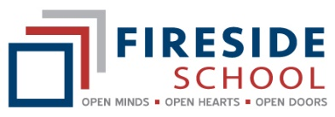
2021 - 2022 Option Selection Form
For the 2021 - 2022 school year, options will be offered in 3 terms. Each term will be 12 weeks in length.
All students will take 6 options over the year.
As some options are very popular, students will only be allowed to take an option once in the year.
Every effort will be made to ensure that students are able to take their most desired option. Students will be required to select 8 options they are interested in taking. Please take your time filling out this form .

Students Name __________________________________ Grade ___________________
(Last and first) (Grade in Sep 2021)

Please check One from this list
- Art - Drawing - $10
- Art - Painting - $10
- Art - Sculpture and Ceramics - $10
- Coding and Robotics - Free
- Digital Marketing – Free
- Drama – Free
- Fibre Arts - $15
- Foods - $15
- French - An Introduction – Free
- Leadership – Free
- Maker Space - $15
- Outdoor Leadership - $50
- Percussion Ensemble – Free
- Photography - $10
- Recreation Fitness - Free
- Shop - $15
Please check Seven from this list
- Art - Drawing - $10
- Art - Painting - $10
- Art - Sculpture and Ceramics - $10
- Coding and Robotics - Free
- Digital Marketing – Free
- Drama – Free
- Fibre Arts - $15
- Foods - $15
- French - An Introduction – Free
- Leadership – Free
- Maker Space - $15
- Outdoor Leadership - $50
- Percussion Ensemble – Free
- Photography - $10
- Recreation Fitness - Free
- Shop - $15
Student Signature_____________________________________________________________
Parent Signature __________________________________ Date ___________________

